CHAPTER 1 - THE PROPHET

**All Lectures Uploaded on YouTube:** [**https://tinyurl.com/fkm9-english**](https://tinyurl.com/fkm9-english)

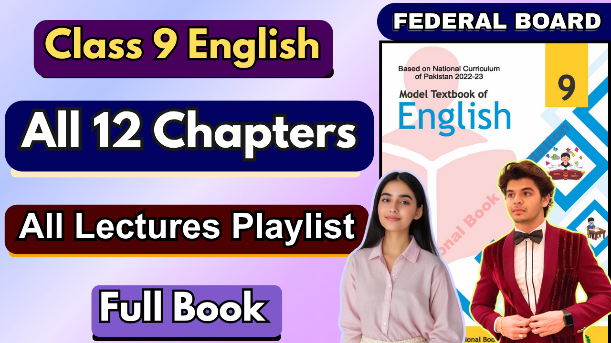

Question/Answers

**1. What does the Holy Quran narrate about mercy?**

**Ans.** The Quran narrates that Hazrat Muhammad Rasulullah (SAW) was sent as Mercy for all the worlds and He confirmed this when he said: "O people, verify am only gifted mercy.

**2. How did Hazrat Muhammad (SAW) treat the nonbelievers after the conquest of Makkah?**

**Ans.** Prophet Muhammad (SAW) displayed remarkable forgiveness and tolerance towards the nonbelievers after the conquest of Makkah. He forgave his enemies and treated them with compassion.

**3. Hazrat Muhammad (SAW) is a "Mercy for all". Explain.**

**Ans.** This phrase highlights Prophet Muhammad's (SAW) compassionate nature and his role as a guide and example for all humanity. He showed mercy in his interactions with people including women, children, non-believers, animals and birds and the environment.

**4. Narrate an example of kindness to animals from the life of Hazrat Muhammad (SAW).**

**Ans.** There was a traveler who was thirsty during his journey. He saw a well and when he came out he saw a dog who was as thirsty as he was so he went into the well and filled his leather sock with water for the dog.



**5. What reward did the traveler get for quenching the thirst of the dog?**

**Ans.** The traveler’s previous sins were forgiven.

**6. How should we treat animals?**

**Ans.** Islam says that we should treat animals with kindness, compassion and respect. We should avoid cruelty and ensure their well-being.

**7. What lesson do you get from the life of Hazrat Muhammad (SAW) and also narrate its significance in the present age?**

**Ans.** The life of Prophet Muhammad (SAW) teaches us valuable lessons about compassion, forgiveness, tolerance and leadership. These qualities are important in today's world to address challenges, conflict, inequality and environmental issues.

**Glossary:**

# Mercy

# Definition: A kind and forgiving feeling toward someone you could punish.

# Concept: Mercy means choosing to be gentle and not hurt someone even though you have the power to do so.

# Example Sentence: The teacher showed mercy by giving Tom another chance to finish his homework.

# Beacon

# Definition: A bright light used to guide or warn; something that inspires or shows the way.

# Concept: A beacon helps people find their path or warns them of danger, just like a lighthouse guides ships.

# Example Sentence: The lighthouse’s beacon helped the ship stay safe during the storm.

# Revered

# Definition: Deeply admired and respected.

# Concept: When someone is revered, many people look up to them and honor them for their good qualities.

# Example Sentence: Nelson Mandela is revered around the world for his fight for equality.

# Epitomized

# Definition: To be the perfect example of something.

# Concept: If someone or something epitomizes a quality, they show that quality in the best way possible.

# Example Sentence: The Olympic athlete epitomized hard work and determination by training every day.

# Legacy

# Definition: Things passed down from the past, like traditions or achievements.

# Concept: A legacy is what people remember or keep after someone is gone, including their actions or ideas.

# Example Sentence: Her grandmother’s legacy of kindness inspired everyone in the family.

# Compassion

# Definition: Feeling sorry for someone’s suffering and wanting to help.

# Concept: Compassion is caring about others’ feelings and doing something to make them feel better.

# Example Sentence: Seeing the injured bird, Mia felt compassion and gently put it in a safe box.

# Inclusive

# Definition: Including everyone; not leaving anyone out.

# Concept: When something is inclusive, it welcomes all people, no matter their background or ability.

# Example Sentence: Our school’s sports team is inclusive, so everyone can join in.

# Encompassed

# Definition: To include a large variety of things.

# Concept: If something encompasses many parts, it covers or contains all of them.

# Example Sentence: The museum tour encompassed art, history and science exhibits.

# Urge

# Definition: To strongly encourage someone to do something.

# Concept: Urging is when you try hard to persuade or push someone to take action.

# Example Sentence: I urge you to study a little each day instead of cramming at the last minute.

# Quenched

# Definition: To satisfy thirst or to put out a fire.

# Concept: Quenching means giving someone water to drink or stopping a fire from burning.

# Example Sentence: After the long run, Sara drank water to quench her thirst.

# Witness

# Definition: To see or watch something happen.

# Concept: A witness is someone who observes an event with their own eyes.

# Example Sentence: We were lucky to witness the beautiful sunset at the beach.

# Reproach

# Definition: To blame or criticize someone.

# Concept: Reproach is showing disappointment or anger at someone’s actions.

# Example Sentence: The coach reproached the player for not trying hard enough.

# Commandments

# Definition: Rules or laws given by a higher power.

# Concept: Commandments are important instructions people follow because they come from a deity.

# Example Sentence: The Ten Commandments teach people how to live good lives.

# Meritorious

# Definition: Worthy of praise or reward.

# Concept: If an action is meritorious, it deserves recognition because it was done well.

# Example Sentence: Her meritorious work on the science project earned her a prize.

# Pardoned

# Definition: Officially forgiven for doing something wrong.

# Concept: To pardon someone is to let them off the hook, so they don’t face punishment.

# Example Sentence: The king pardoned the prisoner and he was free to go home.

# Screeching

# Definition: Making a very loud, high-pitched sound of alarm or pain.

# Concept: Screeching is a sharp, unpleasant noise people or animals make when scared or hurt.

# Example Sentence: The tires were screeching as the car braked suddenly.

# Choose the Correct Option

* 1. **Choose the correct option.**
     1. **The preaching of Hazrat Muhammad Rasulullah ("644) is a beacon of light for humanity. The underlined phrase means**
        1. *A light for guidance for humanity.*
        2. A light for warning
        3. A light for guidance for Muslims only
        4. A light to show path
     2. **Hazrat Muhammad Rasulullah SWT is the epitome of mercy for all the world. The underlined word means:**
        1. Principle
        2. *Embodiment*
        3. Example
        4. Light
     3. **The mother bird started when her chicks were taken away from the nest.**
        1. Flying
        2. searching
        3. *screeching*
        4. Chirping
     4. **Hazarat Muhammad conquered Makkah during which year of His Prophethood (Nabuwat)?**
        1. 21st
        2. 22nd
        3. *25th*
        4. 27th
     5. **"The one with no for others is not pitied".**
        1. care
        2. worry
        3. Patience
        4. *Pity*

**Vocabulary and Grammar**

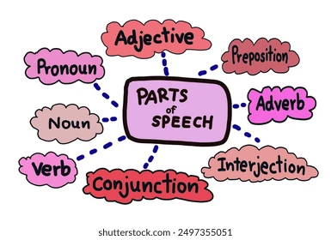

* + 1. **Find the synonyms of the following words by using a thesaurus and also identify the parts of speech they belong to:**
       1. **Cloak**
          1. Synonyms: cape, robe (noun); cover, disguise (verb)
          2. Part of speech: **Noun/Verb**
       2. **Verily**
          1. Synonyms: truly, certainly, indeed
          2. Part of speech: **Adverb**
       3. **Lenient**
          1. Synonyms: forgiving, tolerant, permissive
          2. Part of speech: **Adjective**
       4. **Licking**
          1. Synonyms: beating, thrashing (noun); tasting, touching (verb)
          2. Part of speech: **Noun/Verb**
       5. **Sustainer**
          1. Synonyms: supporter, provider, maintainer
          2. Part of speech: **Noun**
       6. **Harmony**
          1. Synonyms: peace, concord, agreement
          2. Part of speech: **Noun**
       7. **Campaign**
          1. Synonyms: drive, effort (noun); advocate, promote (verb)
          2. Part of speech: **Noun/Verb**
    2. **Consult a dictionary or an online source to find out the pronunciation of the following words.**

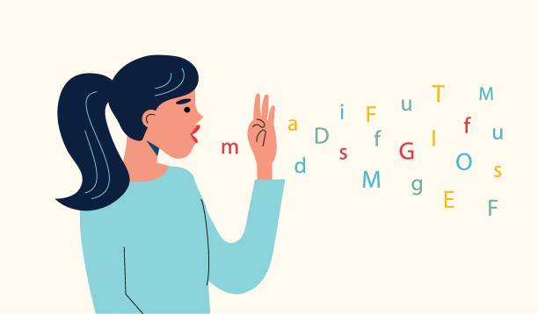

* + - 1. **Myriads**

**Pronunciation: /ˈmɪr.i.ədz/**

* + - 1. **Military**

**Pronunciation: /ˈmɪl.ɪ.tər.i/ or /ˈmɪl.ɪ.teri/**

* + - 1. **Epitomize**

**Pronunciation: /ɪˈpɪt.ə.maɪz/**

* + - 1. **Legacy**

**Pronunciation: /ˈlɛɡ.ə.si/**

* + - 1. **Pardon**

**Pronunciation: /ˈpɑːr.dən/**

* + - 1. **Quench Pronunciation: /kwɛntʃ/**
      2. **Claim**

**Pronunciation: /kleɪm/**

**(To hear the pronunciations, please attend the class or use Google)**

# Adjectives

An adjective is a word that explains and describes nouns and pronouns.

For e.g.

1. 'red hat'. Hat is a noun. ‘Red’ is an adjective because it tells you the description of the hat.
2. 'A quick fox'. Fox is a noun. ‘Quick’ is an adjective because it explains to you what the fox is like.

Adjectives are sometimes formed from nouns or verbs by the addition of a suffix such as

1. -able' (lovable)
2. '-ful' (heedful)
3. '-ish' (foolish)
4. -ive' (combative)
5. '-oust (famous)
6. ‘-y’ (needy).

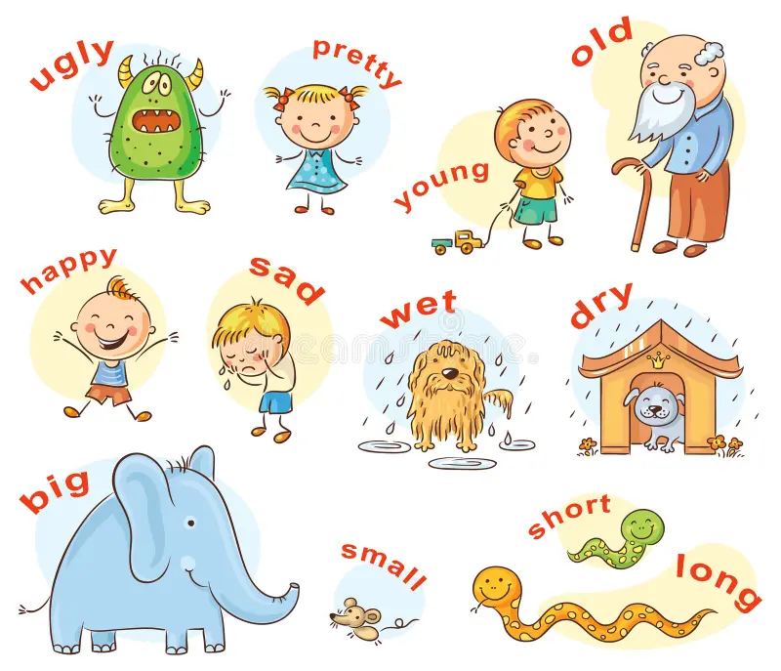

# Exercise:

1. **Form adjectives from the following nouns:**
   1. **duty**
   2. **Ice**
   3. **peace**
   4. **Beauty**

**Answers:**

**Duty → Dutiful**

**Ice → Icy**

**Peace → Peaceful**

**Beauty → Beautiful**

1. **Read the given sentences below and circle the adjectives. Circle the adjectives in the sentences below:**
2. The homeless beggar hasn't eaten in days.  
   **Adjective:** homeless
3. The fox is a sly animal.  
   **Adjective:** sly
4. Mary had a little lamb.  
   **Adjective:** Little
5. The selfish giant didn't allow the children to enter his garden.  
   **Adjective:** selfish
6. The foolish dog barked at its reflection and lost its food.  
   **Adjective:** foolish

# Conditional Sentences

# Sentences that show a situation and what will or might happen because of it. A conditional sentence has two parts:

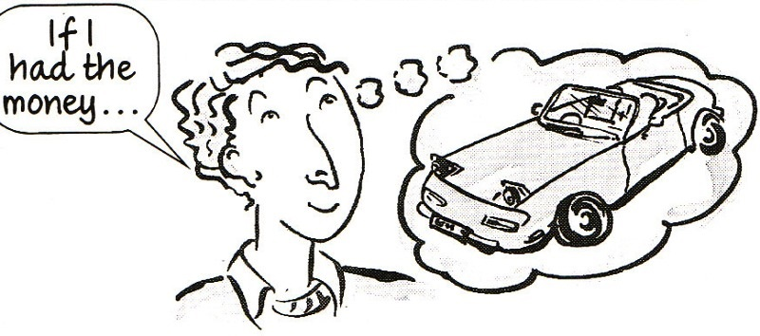

# the “if” part (the condition)

# the result part (what happens if the condition is met).

# Example: If you study for the test, you will do well.

## Structure of Conditional Sentences

**A conditional sentence usually has two parts:**

1. The "if" clause (condition): This states the condition.
2. The result clause (main clause): This states the result if the condition is fulfilled.

**For example:**

* + If it rains, I will bring an umbrella.
    - *Condition*: If it rains.
    - *Result*: I will bring an umbrella. (mail clause)

## Types of Conditional Sentences

1. **Zero Conditional:**
   * Used for general truths or laws of nature where the result is always true when the condition is met.
   * Structure: *If + present simple, present simple*
   * Example: If you heat water to 100°C, it boils.
2. **First Conditional:**
   * Describes a real or possible situation in the future.
   * Structure: *If + present simple, will/shall + base verb*
   * Example: If I study hard, I will pass the exam.

# Proof-reading Exercise:

**Paragraph #1** Did you know that bats are mammals? We know they are mammals just like us because they are warm-blooded. They are the only mammals that know how to fly. Bats are nocturnal, which means they sleep during the day and are awake at night.

**Paragraph #2** Bees are interesting animals. A honey bee can fly at a speed of 15 miles per hour. A hive of honey bees has about 40,000 bees in it. The honey bee has five eyes! A worker bee will make 1/12th of a teaspoon of honey over its lifetime. Bees have been making honey for about 150 million years.

**Paragraph #3** Did you know that a person can live without food for more than a whole month? A person can only live for about one week without water. We need water more than we need food. About 97% of Earth's water is in the oceans. Just 3% of the Earth's water can be used for drinking. Approximately 75% of the world's freshwater is frozen in the North and South polar ice caps.

